PAUWELS TRAVEL BUREAU LTD
Mailing Address: 43 Condor St, Kitchener, ON N2K 0B2
519-753-2695 | tours@pauwelstravel.com
www.pauwelstravel.com | Ont. Reg. #50028250

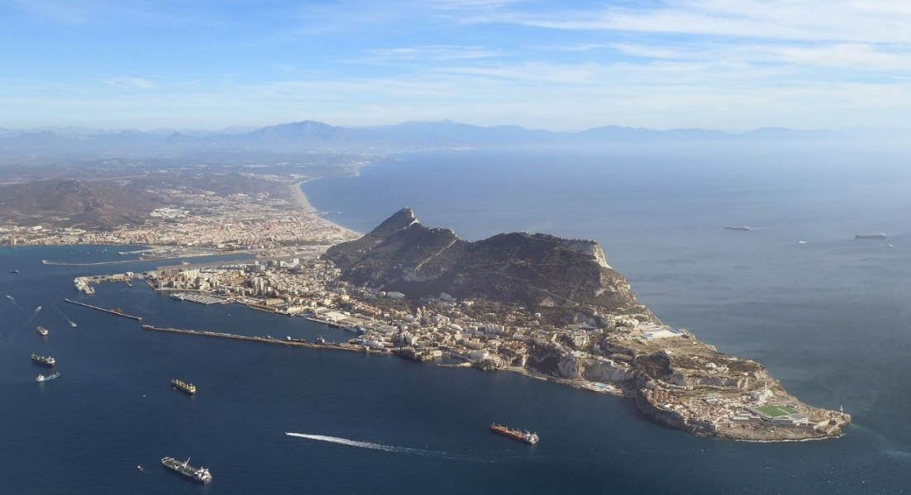

Spain’s Costa Del Sol

12 days, from Tuesday, November 24, to Saturday, December 5, 2026

Even in darkest November, blue skies and balmy temperatures can normally be enjoyed on the famous “Coast of the Sun,” in Spain’s historically and culturally fascinating southern region of Andalusia. At that time, the very mild local Mediterranean climate features average daytime high temperature in the low twenties centigrade. Our tour includes local sightseeing as well s excursions to the great city of Malaga, to legendary Gibraltar, and to picturesque towns such as Marbella, Ronda, and Mijas; an optional excursion to Granada will also be available. We will stay in the resort of Torremolinos, in the first-class/four-star hotel Melia Costa del Sol, overlooking the beach, in deluxe sea view rooms, and enjoy a sumptuous daily buffet breakfast and dinner including wine and/or beer. The tour will also feature talks on the history of the region and Spain in general by your tour escort, historian Jacques Pauwels, PhD, author of books such as ‘Beneath the Dust of Time: A History of the Names of Peoples and Places’ (new edition, 2025).

Please note that this tour is limited to 20 participants and that the booking deadline is Monday, August 15.

Tour Cost: $4,775.00 CAD*
*Roundtrip From Toronto, Based on Double Occupancy
Land Only: 3,375.00 CAD, based on double occupancy
Single room supplement: $1,100.00 CAD

PROPOSED ITINERARY

Day 1 – Tuesday, November 24: Around 9 PM, departure from Toronto Pearson Airport to Amsterdam with KLM Royal Dutch Airlines.

Day 2 – Wednesday, November 25: Arrival in Amsterdam in late morning and connecting flight to Malaga, Spain. Arrival in Malaga in mid-afternoon, and short transfer to Torremolinos, hub of Spain’s famous Mediterranean playground, the Costa del Sol. Check into one of the resort’s top hotels, the first-class/four-star Melia Costa del Sol, centrally located and overlooking Bajondillo Beach, the town’s most central and iconic beach. We will be staying in deluxe sea-view rooms, and during our entire stay in this great property, a sumptuous and generous buffet-style breakfast as well as dinner will be offered daily; with dinner, beverages will be included, not only mineral water and soft drinks but also wine (white, rosé, and red) and beer in reasonable quantities. The hotel bar features entertainment most evenings, including Spanish and international singers, dancers (also Flamenco!), magicians, etc. For mostly highly favourable comments from guests as well as pictures, see Tripadvisor.

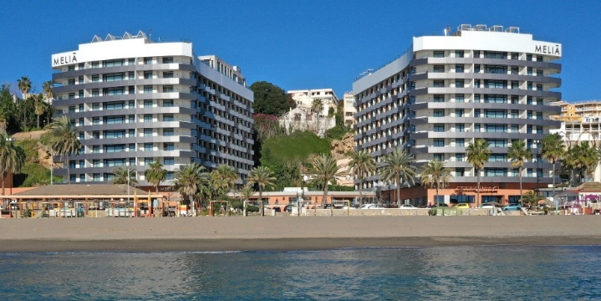
< The first-class Hotel Melia Costa del Sol

Day 3 – Thursday, November 26: After breakfast, leisurely guided walking tour of Torremolinos, with sights such as La Carihuela fishermen’s quarter and beach; the church of San Miguel; the Calle San Miguel main street lined with shops; the extravagant mansion known as Casa de las Navajas; La Bateria city park; and of course the medieval Torre Pimentel, a.k.a. Torre de los Molinos, “tower of the mills,” which gave its name to the town. The afternoon is free for individual exploring or shopping, Or how about a stroll along the Paseo Maritimo, part of a hiking trail called La Senda Litoral (Coastal Path), stretching along the entire length of the Costa del Sol and featuring beaches, cliffs, and exceptional landscapes; in Torremolinos it passes along no less than six beaches: Los Álamos, Playamar, El Bajondillo (where our hotel is located), La Carihuela, Playamar, and El Saltillo. For more information on local sightseeing, shopping and other things to do, see https://turismotorremolinos.es/en/discover/places-of-interest

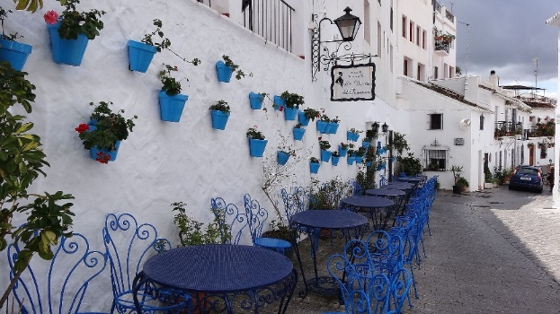
Day 4 – Friday, November 27: After breakfast, visit to Mijas, a quaint, typically Andalusian white-washed village in the hills overlooking the Costa del Sol, famous for its donkey taxis! On to Marbella, favourite resort of the international jet set; its past and present residents have included celebrities such as Sean Connery, George Clooney, Novak Djokovic, and Antonio Banderas. Marbella has an impressive yacht harbour, a picturesque old town, chic shopping, and many attractive restaurants to enjoy lunch. Afternoon return to Torremolinos via some more popular resorts along the Costa del Sol, such as Fuengirola and Benalmadena.
Picturesque Mijas >

Day 5 – Saturday, November 28: Full-day excursion to Malaga, an important Mediterranean seaport since the time of the Phoenicians and one of the major urban centres of Andalusia. The city also boasts beaches, superb architecture, fine museums, and excellent shopping, cuisine, and wine! Our tour includes the foremost historical sites, such as the Roman Theatre; the huge Cathedral in Renaissance style; and views of the two hilltop fortresses dating back to the time when the Moors (i.e. Arabs) ruled this land, the Alcazaba and the Gibralfaro, where one can enjoy a fabulous panoramic view of the city, the harbour, and the blue Mediterranean Sea. Free time for lunch and some shopping in the city’s central market, Mercado Atarazanas.
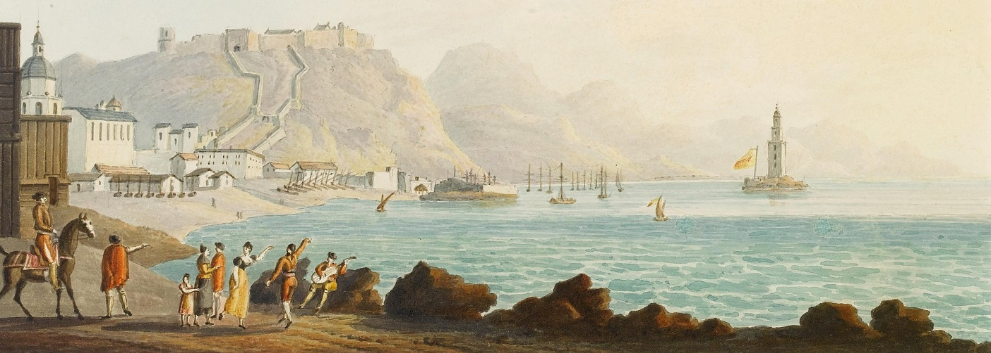
Malaga’s harbour and hilltop forts on an early 19th-c. painting by Thomas Staunton.
Day 6 – Sunday, November 29: Morning free. You may want to check out Torremolinos’ “Rastro” flea market near the bullring, which operates 9 am to 2 pm and features antiques, and all sorts of collectibles. In the afternoon, excursion to the town of Antequera for a visit to another UNESCO World Heritage Site, featuring dolmens and other megalithic monuments, described as “one of the most remarkable architectural works of European prehistory and one of the most important examples of European Megalithism.” On to way back to our hotel, visit to the beautiful botanical and historical garden In the afternoon, on the way back to Torremolinos, visit to to the beautiful botanical garden of La Conception, “a natural oasis, the best-preserved subtropical landscape garden in Europe.”

Day 7 – Monday, November 30: Full-day excursion to the fascinating old town of Ronda, spectacularly perched on top of a big rocky hill cut in two by a 120 meter deep gorge; the two parts of the town are connected by an 18th-century stone bridge, offering breathtaking views of the surrounding countryside, the scenic Serranía de Ronda, reputed to be one of the most beautiful areas of Andalusia. Ronda was settled by Phoenicians, Romans, Visigoths, and Arabs, and was one of the last outposts of Islamic rule in Andalusia. The town is also considered to be the cradle of bullfighting and boasts the oldest bullring in Spain, built in 1785. Our local tour will focus on these sites and monuments as well as the well-preserved medieval Arab baths; the Church of Santa María Mayor, a former mosque; and Mondragón Palace, an architectural pastiche of Islamic, Gothic and Renaissance styles, with a beautiful garden. On the return to Torremolinos in the afternoon, we briefly visit Setenil de las Bodegas, a village nestled under a huge rock towering over a narrow river gorge!

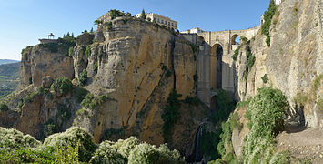
< Spectacular Ronda, with the Puente Nuevo

Day 8 – Tuesday, December 1: Today we return to Malaga by train, which normally takes only 20 minutes, to visit the museum dedicated to the world-famous Spanish artist Pablo Picasso, who was born and lived here until he was 10; the museum features about 200 pieces of his work and is housed in an elegant 16th-century palace. On to the Malaga Museum, dedicated to archeology as well as fine art, featuring an impressive collection of paintings from 15th to the 20th centuries. Afterwards you will be free to enjoy Malaga on your own, perhaps visiting more museums and/or monuments such as Casa Natal Picasso, the home of Picasso’s birth, or one of the two Moorish castles. Tour participants can stay in the city as long as they want, returning by train to Torremolinos at their convenience.
Day 9 – Wednesday, December 2: Full-day excursion along the coast to the southern tip of Spain for a thorough visit to Gibraltar (120 km), the legendary rock at the entrance to the homonymous strait between Europe and Africa. Your tour guide will tell you the fascinating history of the Strait of Gibraltar, known in Antiquity as the “Pillars of Hercules,” and its connection with the dollar! In Gibraltar, our sightseeing will include Europa Point, from which the coast of Africa can be seen; the “Upper Rock” with its military installation and nature reserve where the famous monkeys live; St Michael's Cave, an impressive natural grotto inhabited during the neolithic; and of course the busy main street lined with shops, pubs and restaurants. Also an opportunity to take an optional cable car ride to the top of the Rock! Return to Torremolinos in late afternoon.

Day 10 – Thursday, December 3: Free day to relax and/or explore Torremolinos on your own. Don’t miss the Thursday morning open-air market (mercadillo), featuring fresh fruit, vegetables, plants, clothing, shoes, and household items. If there is sufficient interest, an optional excursion will be offered to Granada, another UNESCO World Heritage Site, with its wonderful Alhambra Palace.

Day 11 - Friday, December 4: Morning free. After a group lunch at the hotel, transfer to Malaga Airport in time for the late-afternoon departure of our KLM flight to Amsterdam. Arrival and transfer to an airport hotel via the hotel’s shuttle service.

Day 12 – Saturday, December 5: After a leisurely breakfast, transfer (via hotel shuttle again) to the airport in time for the KLM flight’s 1:30 PM departure to Toronto. Arrival in Toronto around 4 PM.

Tour Cost: $4,775 CAD*
*Roundtrip from Toronto, Based on Double Occupancy
Land Only: $3,375 CAD, based on double occupancy.
Single room supplement: $1,100.00 CAD

Included in the Tour Price Are:
- Accommodation in the four-star/first-class hotels Melia Costa del Sol in Torremolinos (in deluxe sea view rooms), and one night in a four-star airport hotel in Amsterdam, based on double occupancy – the supplement for “single use of a double room” is $1,100;
- Transfers, sightseeing, and excursions as shown in the itinerary;
- Meals: breakfast and dinner daily, and wine, beer, soft drinks and/or water included with dinner;
- Gratuities for local guide(s).

Not Included
- Beverages & meals other than those outlined above.
- All expenses of a personal nature.
- Coach driver gratuities: approximately 25 euros per person.
- All items of a personal nature.
- Travel insurance. Please contact the office for premiums.

Registration

Please book seat(s) on the “Costa Del Sol” tour on November 24th to December 5th, 2026.

Please be prepared to pay a deposit of $1200 per person and any applicable insurance premium at time of registration. Balance is invoiced no later than 60 days prior to departure.

WE REQUIRE A COPY OF YOUR PASSPORT (INFORMATION PAGES ONLY) VALID 6 MONTHS AFTER TOUR TO BE SENT IN WITH YOUR REGISTRATION FORM.

PASSPORT NAME(S):
Surname First Middle(s)

Date of Birth (ddmmmyyyy):

Surname First Middle(s)

Date of Birth (ddmmmyyyy):
Address: City:

Postal Code: Phone: Cell Phone:

Email:
If traveling alone, is a single room required? Yes No
If sharing, what is your bed preference: twin (2 beds) double (1 bed) ?
SPECIAL REQUIREMENTS: Please list any dietary requests, allergies, special physical needs, or frequent flyer numbers etc., below. We cannot ensure requests made 30 days or less prior to departure will be possible.

INSURANCE: Review plans and rates by clicking here or calling the office. Record your quoted premium below:
All-Inclusive: Emergency Medical: Non-Medical/Trip Cancellation:
Decline Insurance:
PAYMENT: Cheque payable to Pauwels Travel Bureau LTD, e-transfer to tours@pauwelstravel.com or call the office to provide credit card (Visa, Mastercard, American Express) to Sandra or Jessica.
Amount To Pay: ______________
CONSENT: “I/we have read and agree to the terms and conditions attached to the tour program, have selected or declined insurance, indicated any special requests, and authorize payment of the above amount.”

Date_______ Signature____________________________

Date_______ Signature____________________________

PAUWELS TRAVEL BUREAU LTD.
Mailing Address: 43 Condor St, Kitchener, ON, N2K 0B2
Tel: 519-753-2695/1-800-380-3974 – Fax: 519753-6376 - Email: tours@pauwelstravel.com
TERMS & CONDITIONS
RESERVATIONS AND DEPOSITS:
Reservations should be made as early as possible to ensure the departure of your choice. No reservations will be accepted without a deposit and signed registration form. Deposit amounts vary by tour and are listed in the registration form.
REFUND OF UNUSED ARRANGEMENTS:
Because the rates of Pauwels Travel Bureau Ltd. are based on group participation, no refund can be made for any tour accommodation or tour service, or tour feature not taken. If cancellation occurs while the tour is in progress, no refund can be made for the tour portion not taken. We strongly suggest that to allow for any unexpected contingencies, you purchase the all-inclusive insurance.
CANCELLATION POLICY:
Refund of deposit is made if cancellation is received in writing by Pauwels Travel Bureau Ltd. at least 91 days prior of the departure date of the tour less a $250.00 non-refundable administrative fee per person. For cancellation received in writing 90 days prior or less the following cancellation penalties apply for tour costs:
- 120 days to 91 days before departure: 45% of tour cost
- 90 to 31 days before departure: 65% of tour cost
- 30 – 0 days prior to departure: 100% of tour cost
RESPONSIBILITY:
The acceptance of the initial service to be provided under the tour shall be considered an acceptance by the tour member of those conditions. We also reserve the right to decline, to accept or retain any person as a member of the tour. We reserve the right without notice, to withdraw any part or all of the tour. Factors such as airline schedule changes, hotel overbookings, inclement weather, travel warnings by the Canadian Government etc. may necessitate changes in the itinerary. There may also be other circumstances in which changes become necessary or advisable. By commencing the tour, I agree to the release and agreement as included below.
RELEASE & AGREEMENT:
By placing my deposit, submitting my registration, and commencing the tour I understand and agree to the following:
1. That all tours are delivered in conjunction with other service providers, including but not limited to travel agent and booking services, airlines, hotel and accommodation providers, transportation providers including but not limited to coach, train and ferry services, restaurant providers, and local guides. We shall not be held responsible for the failure by any person or company to render any transportation, lodging or other travel service to be provided on the tour. All hotels, transportation and other travel services are provided subject to all the terms and conditions under which they are offered to the public generally.
2. I know that tour programs include walking and may including hiking and fitness programs that have potentially hazardous activities associated with them. I should not participate prior to approval by my physician. I assume any and all other risks associated with these events included but not limited to falls, contact with other participants, the effects of the weather including high heat and/or humidity.
3. To release, indemnify and hold harmless Pauwels Travel Bureau and their affiliates (which term shall include parents, subsidiaries, officers, directors, shareholders, agents and employees of Pauwels Travel Bureau as well as Pauwels Travel themselves) (the “Released Parties”) from, and agree not to sue the Released Parties for, any claims that I may have arising from, or in connection with, any personal injury, bodily injury, mental anguish, emotional distress, physical, property or other damage that I may suffer from any cause whatsoever related in any way to my participation in this tour. Without limiting the generality of the foregoing, I release, indemnify, and hold harmless the Released Parties from, and agree not to sue them for any personal injury, bodily injury, mental anguish, emotional distress, physical, property or other damage that I may suffer from the Released Parties’ negligence other than from intentional or reckless acts by such parties. I further agree to release, indemnify and hold harmless the Released Parties from any and all acts of God, war (whether declared or undeclared), terrorist activities, incidents of politically motivated violence, illness or quarantine, strikes or government restrictions or the acts or omissions of any other agents over which the Released Parties have no direct or indirect control, including, without limitation, airlines, railways, bus companies, hotels, shipping companies, guides and sub- contracted agents or tour operators. This release also includes activities not offered that may be considered risky. I further release any Tour Directors, bus drivers or other individuals involved in my tour.
4. That the air carrier’s liability for loss of or damage to baggage or property, or for death or injury to person, is limited by their tariffs, or the Warsaw Convention, or both.
5. That Pauwels Travel Bureau shall have no liability or responsibility for me when I am absent from activities, such as visits to friends or relatives or during pre-tour/post-tour option periods if the pre-tour/post-tour period does not include the services of a Tour Director.
6. To abide by directions of my Tour Director or other leadership personnel during my tour. Failure to do so may result in my termination from tour immediately. I understand that to disobey such rules or directions are to waive the right to any refund, and that I may be sent home at my own expense. The participant and family undertake full financial responsibility for any damage caused by the participant and agree to pay his/her return home on the first available flight, should his/her behavior be deemed detrimental to the welfare of the group.
7. To abide by all local laws when in Canada and abroad, including those concerning drugs and alcohol. (Minors must have parents’ permission to use alcohol even if the local law would otherwise permit them to). I understand that if I abuse or disobey such laws, even unintentionally, I waive my right to a refund, and Pauwels Travel may send me home at my own expense. I also understand that should local authorities be involved; I will be subject to the laws of the country I am visiting.
8. That if I become ill or incapacitated, Pauwels Travel and its employees, or a designated chaperone may take any action they deem necessary for my safety and well-being, including securing medical treatment (at my own expense) and transporting me home. In the event of a medical emergency, Pauwels Travel will attempt to cause appropriate treatment to be administered, and the traveller authorizes Pauwels Travel to do so. Pauwels Travel, however, makes no warranty that it will be able to cause effective (or any) emergency treatment to be administered.
9. That Pauwels Travel may use any film likenesses taken of me and any of my comments while on a tour for future publication and use my contact information for future Pauwels Travel communications.
A WORD ABOUT GROUP AIRFARES:
Please note that when booking one of our air inclusive tours, Pauwels Travel has negotiated reduced rates with the airline that we are able to confirm and lock in up to 359 days before travel. While it is wonderful to share the savings and flexibility this provides with you, our valued guests, the privilege does come with some restrictions. In some cases, it may not be possible to collect frequent flyer miles, you may not be able to check in online 24 hours before travel, or you may need to try checking in with your ticket number rather than your booking reference. Additionally, most airlines do not allow advanced seat-selection on group airfares. It is the airline’s policy, not ours, that prevents us from assigning specific seats. If a request is made, it is passed on to the airline by our staff when they submit the names to the airline 60 days prior to departure but no requests are guaranteed. Our staff will not be able to aid in advanced seat selection if the airline does not allow it on the group airfare. If a certain type of seat is indispensable to you, we suggest that you book our tour on a “land only” basis and make individual flight arrangements, in which case you may be able to get the seat of your choice; Pauwels Travel would be happy to assist you with that reservation. We will offer you the best fare available, but please note that this can only be done once a tour is a guaranteed departure because individual airfare conditions are stricter than the conditions of the group airfare rate. We thank you in advance for your kind understanding of the above!

